*

|  |  |  |
| --- | --- | --- |
| BEC Bagalkot - Admissions 2022, Fees, Courses, Ranking, Placement | Basaveshwar Engineering College (Autonomous) | Mechanical Engineering Association |
| S. Nijalingappa Vidyanagar, Bagalkot-587102 |
|  |
| *Department of Mechanical Engineering* |
| **M**echanical **E**ngineering **A**ssociation |

|  |  |  |  |
| --- | --- | --- | --- |
|  |  |  | Date: 05-02-2025 |

**LIST OF EVENTS**

|  |  |  |  |  |
| --- | --- | --- | --- | --- |
| Date | | Event | | Description |
| 6th December 2024 | | Inauguration of MEA | | In the presence of HOD and other faculty members, discussion of future events, “Job opportunity in Mechanical Engineering” Talk by Mr. **Jayatirth Nadagouda** Senior Manager STELLANTIS Bengaluru and **Mr. Vaman Kulkarni** Project Manager BOSCH Bengaluru |
|  | | Events conducted under **FRESCO 2024** | |  |
| 15th December 2024 | | “What Next After B.E. Degree”  Talk by Dr. Naveen Shirur  Germany University | | 40 students participated. His experience in Research at Germany University. Talk on   * The research area: Sensors used in vehicle air bag to prevent loss of human lives. * Efforts students should take up to face the upcoming challenges |
| **MEA Sports** | | | | |
| 1 | **Cricket**  Total no. of teams: 12  Players per team:11 | | Winner: Sandeep & Team  3rd year  Runner up: Praveen Chippalakatti 4th year | |
| 2 | **Volley Ball**  Total no. of teams: 7  Players per team:6 | | Winner: Mahesh & Team  2rd year  Runner up: Iranna & Team 4th year | |
| 3 | **Tug of war**  Total no. of teams: 6  Players per team:7 | | Winner: Sachin & Team  3rd year  Runner up: Karthik & Team 3rd year | |
| 4 | **Badminton**  **Singles**  Total players: 51  **Doubles**  Total players: 35 | | Winner: Isak Momin  Runner up: Abhishek C K  Winner: Udhav W. & Prajwal S.  Runner up: Sameer and Isak Momin | |
| 5 | **Chess**  Total players: 35 | | Winner: Shankar M. Kure Ist year  Runner up: Praveen K. Hallur 2nd year | |
| 6 | **Carrom**  Total Teams: 36  Players per team:2 | | Winner: Amit & Vinayak 4th year  Runner up: Chetan & Nagaraj 3rd year | |

**FRESCO 2024**

**Mechanical Engineering Association (MEA)**

Committees

Following are the details of committees formed for the smooth conduct of MEA Inaugural Function for the Academic Year 2024-25.

All the faculties are requested to take help of the students mentioned for concerned work.

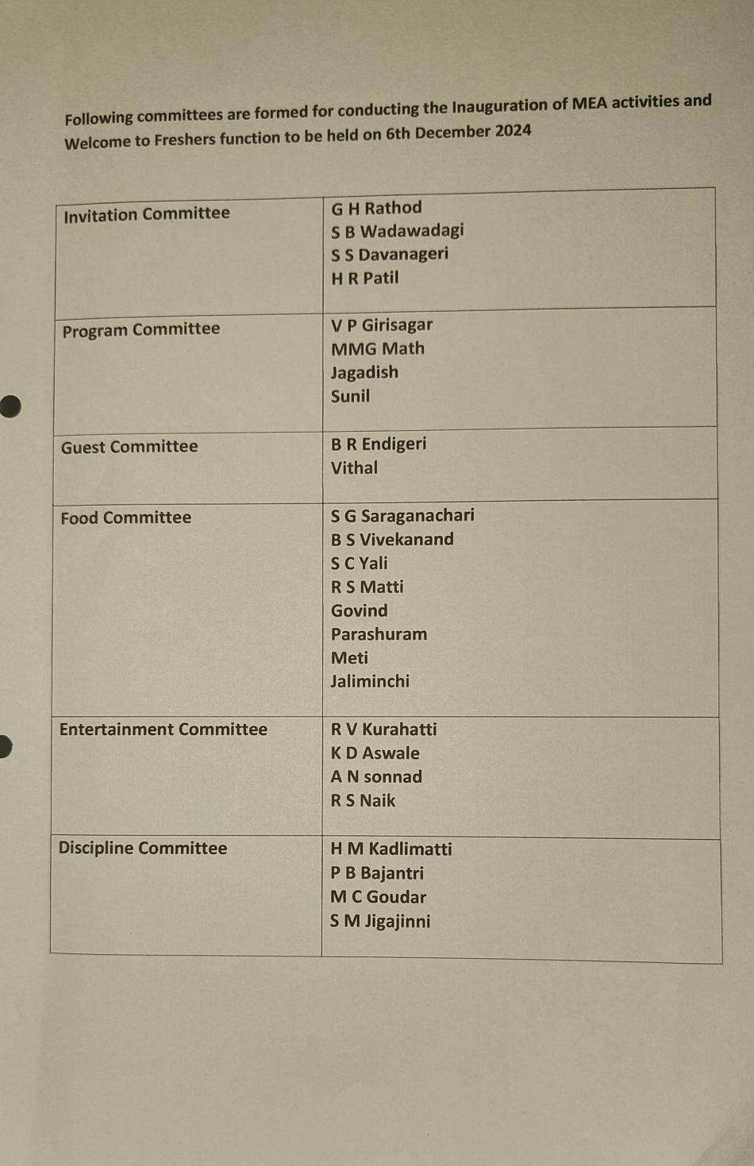

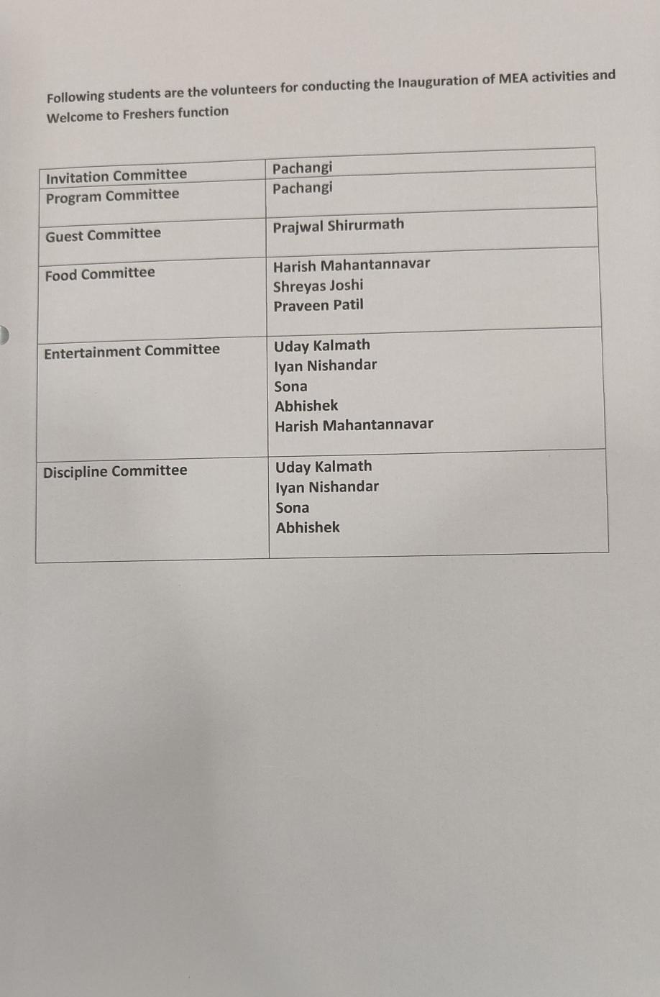

Dress code for Ist year students: White shirt and black pant

* **Mr. Praveen Chippalakatti** General Secretary 2024-25 Batch

|  |  |  |
| --- | --- | --- |
| Co-Ordinator-MEA  (Dr. R. V. Kurahatti) |  | HoD-MED  (Dr. V. V. Kuppast) |

|  |
| --- |
|  |
|  |
|  |
|  |
|  |
|  |

|  |  |  |
| --- | --- | --- |
|  | Basaveshwar Engineering College (Autonomous) | Mechanical Engineering Association |
| S. Nijalingappa Vidyanagar, Bagalkot-587102 |
|  |
| *Department of Mechanical Engineering* |
| **M**echanical **E**ngineering **A**ssociation |

PHOTOS

|  |
| --- |
|  |
|  |
|  |

|  |
| --- |
|  |
|  |
|  |
|  |
|  |
|  |
|  |
|  |

Mechanical Engineering and Civil Engineering First Year Students attended a talk by Prof. Vijay Desai on 24-12-2024 in Gallery Hall. The topic was “Importance and courier opportunities for Non-IT core Engineering courses”.

From,

General Secretary

Department of Mechanical Engineering

BEC Bagalkot

Date: 31-12-2024

To,

The HOD

Department of Mechanical Engineering

BEC Bagalkot

Sub: Reference to the total expenses of Inaugural function and sports conducted by MEA for the academic year 2024-25 (on going).

Respected Sir,

With the above cited reference, the bill amount for the same is given to the MEA.

|  |  |  |  |  |
| --- | --- | --- | --- | --- |
| Sl No. | Items | Amount  (In Rs) | Quantity | Total amount  (In Rs) |
| 1 | Prakash digital expenditure  dt: 6-12-2024 | 2332=00 |  | 2332=00 |
| 2 | Veerabhadreshwar Stores  Xerox, Papers etc. | 707=00 |  | 707=00 |
| 3 | Bokke and Flower | 1400=00 |  | 1400=00 |
| 4 | Light 4 Nos. | 1200=00 |  | 1200=00 |
| 5 | Dinner | 165=00 | 400 | 66000=00 |
| 6 | Sports equipment |  |  | 14500=00 |
| 7 | Sports equipment |  |  | 13480=00 |
| 8 | Gift |  | 1 | 700=00 |
| Total expenses | | | | 100319=00 |

Thanking you

Yours Sincerely

General Secretary